Name of Student : Raghav Mahesh Sarda PRN: 25070122235
Subject: Programming with Java Semester: III
ASSIGNMENT No : 8 Year: AY 2026-27
TITLE : Super Keyword In Java

Problem Statement
Write a Java program to demonstrate the use of the super keyword in inheritance.

Learning Objectives
To demonstrate the use of the super keyword for accessing parent class members.

Program:
EmployeeManagerSuperKeyword.java
// Assignment 8 - Exercise 1: Employee and Manager using super keyword
import java.util.*;
class Employee // Parent class
{
String name;
int id;
Employee(String n, int i) // Parent constructor
{
name=n;
id=i;
}
void display() // Parent display method
{
System.out.println("\n-- Employee Details --");
System.out.println("ID: " +id);
System.out.println("Name: " +name);
}
}

class Manager extends Employee // Child class
{
double bonus;
Manager(String n, int i, double b) // Child constructor
{
super(n, i); // Calling parent constructor using super
bonus = b;
}
void display() // Child display method overriding parent
{
super.display(); // Calling parent method using super
System.out.println("Bonus: $" + bonus);
}
}

public class EmployeeManagerSuperKeyword
{
public static void main(String args[]) // Main Method
{
Scanner sc = new Scanner(System.in);
System.out.print("Enter Manager ID: ");
int mid = sc.nextInt();
sc.nextLine(); // Consuming leftover newline
System.out.print("Enter Manager Name: ");
String mname = sc.nextLine();
System.out.print("Enter Manager Bonus: ");
double mbon = sc.nextDouble();

Manager m = new Manager(mname, mid, mbon); // Creating manager object
m.display(); // Displaying details
sc.close();
}
}

Vehicle.java
// Assignment 8 - Exercise 2: Vehicle Insurance System using super keyword
import java.util.*;
class Vehicle // Parent class
{
String regNo;
String brand;
Vehicle(String r, String b) // Parent constructor
{
regNo=r;
brand=b;
}
}

class Insurance extends Vehicle // Child class
{
String policyNo;
double premium;
Insurance(String r, String b, String p, double amt) // Child constructor
{
super(r, b); // Calling parent constructor using super
policyNo = p;
premium = amt;
}
void showDetails() // Method to display all details
{
System.out.println("\n-- Insurance Details --");
System.out.println("Vehicle Reg No: " + super.regNo); // Accessing parent variable using super
System.out.println("Vehicle Brand: " + super.brand); // Accessing parent variable using super
System.out.println("Policy Number: " + policyNo);
System.out.println("Premium Amount: $" + premium);
}
}

public class VehicleInsuranceSystem
{
public static void main(String args[]) // Main Method
{
Scanner sc = new Scanner(System.in);
System.out.print("Enter Vehicle Registration No: ");
String vr = sc.next();
System.out.print("Enter Vehicle Brand: ");
String vb = sc.next();
System.out.print("Enter Policy Number: ");
String ip = sc.next();
System.out.print("Enter Premium Amount: ");
double ia = sc.nextDouble();

Insurance ins = new Insurance(vr, vb, ip, ia); // Creating child object
ins.showDetails(); // Displaying details
sc.close(); // Closing scanner
}
}

Output:
EmployeeManagerSuperKeyword.java
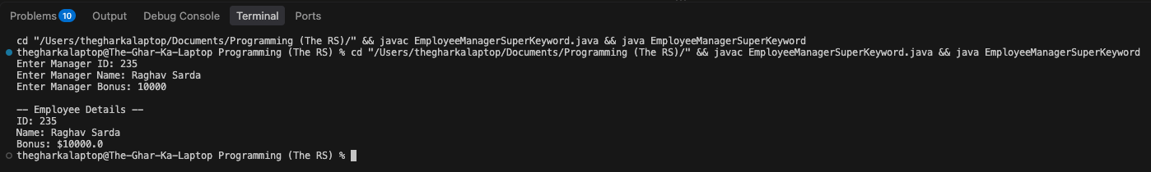

Vehicle.java
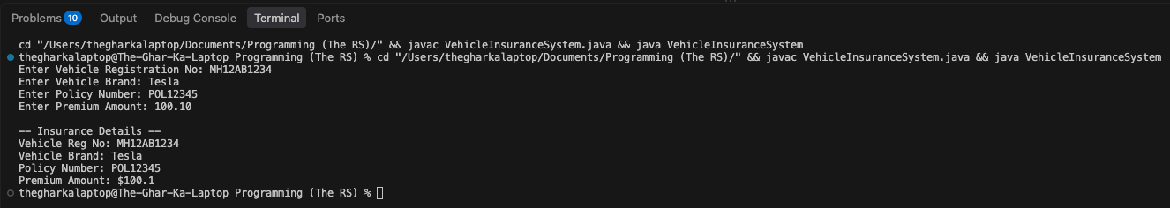

Conclusion:
In this assignment, the super keyword was utilized to resolve naming conflicts, invoke parent class constructors, and access parent class methods and properties within a child class. This demonstrated how inheritance hierarchies can be effectively managed while maintaining organized object initialization.

